UG Program in Artificial Intelligence and Data Science

MICROPROJECT REPORT (PHASE 2) ON

SMART WASTE CLASSIFICATION
USING COMPUTER VISION

Course Name: Deep Learning (ADCOR1PC301)

Submitted by:
Name: Tanmay Badhe
Roll No.: 33
PRN: 124BTAI1026

Name: Swayam Netke
Roll No.: 33
PRN: 124BTAI1066

Class: TYAIDS-03

Submitted to:
Department of Artificial Intelligence and Data Science
Shah and Anchor Kutchhi Engineering College, Chembur - 400088
Academic Year: 2026-27

Report preparation status: implementation notebook supplied; execution results pending.

ABSTRACT
Improper disposal and mixing of recyclable materials reduces recovery efficiency, increases landfill dependence, and creates additional hazards for manual sorting workers. This Phase 2 microproject develops a computer-vision workflow to classify a photograph of a single waste item into six categories: cardboard, glass, metal, paper, plastic, and residual trash. The publicly available TrashNet dataset contains 2,527 labelled images. The implementation notebook includes image-integrity screening, removal of contradictory duplicates, grouping of visually near-identical photographs, and a stratified 70:15:15 training, validation, and test split. It compares a hand-crafted-feature SVM, a CNN trained from scratch, and ImageNet-pretrained ResNet-50, MobileNetV3-Large, and EfficientNet-B0 models. The transfer-learning models use frozen-head training followed by fine-tuning, with class-weighted cross-entropy and early stopping. Evaluation code measures accuracy, macro precision, recall and F1-score, confusion matrices, sorting-specific errors, model cost, and confidence-based manual review; ONNX export and INT8 quantisation are also included. The supplied notebook contains no executed outputs, so quantitative findings cannot yet be claimed. The project provides a reproducible evaluation and deployment-oriented foundation for smart bins and material-recovery facilities.
Evidence note: all methodological settings below are grounded in the uploaded notebook and project draft. "Pending run" means the notebook has code for the output but no saved execution result.

1. INTRODUCTION

1.1 Problem Statement
Waste streams frequently contain mixed recyclable and non-recyclable items. Manual classification in collection bins and material-recovery facilities (MRFs) is labour-intensive, inconsistent, and can expose workers to glass fragments and contaminated material. Incorrect sorting also reduces the quality of material sent for recycling. This project investigates whether deep learning can reliably identify a waste item from its RGB photograph while respecting the compute limitations of a smart-bin controller.

1.2 Objectives
- Prepare a six-class waste-image dataset and reduce leakage from exact or near-identical duplicates.
- Implement and compare one classical baseline, a CNN trained from scratch, and three pretrained convolutional architectures.
- Evaluate each trained model using held-out accuracy, macro precision, macro recall, macro F1-score, class-level outputs, and confusion matrices.
- Select an edge-suitable model using validation macro-F1 under a pre-defined 2-GFLOP budget.
- Examine sorting impact, inference latency, interpretability, confidence-based manual review and quantised deployment.

1.3 Scope and Expected Outcome
The system handles a single predominantly visible object in a 224 × 224 RGB image. Its six predicted categories are cardboard, glass, metal, paper, plastic and residual trash; it does not directly recognise organic, sanitary or hazardous waste. Intended outputs are a comparative evaluation of the five methods, a selected six-class model, prediction confidences, explainability images, and an ONNX deployment candidate. Multiple overlapping objects and live conveyor control are outside the current scope.

1.4 Phase 1 to Phase 2 Progress
Phase 1 proposed image-based classification using TrashNet or a related dataset, a baseline CNN and a lightweight transfer-learning architecture, with standard classification metrics and possible smart-bin deployment. Phase 2 moves from this proposal to a detailed PyTorch notebook implementing the data audit, group-aware split, SVM features, scratch CNN, ResNet-50, MobileNetV3-Large and EfficientNet-B0, a common training recipe, validation-based selection and deployment-oriented analyses. MobileNetV3-Large replaces the proposed MobileNetV2 candidate. The earlier broad "organic waste" category is replaced by TrashNet's actual "trash" label; this prevents claiming a class the chosen dataset does not contain. Source code is prepared, but the uploaded copy contains no run logs or numeric model results.

2. IMPLEMENTATION AND METHODOLOGY

2.1 Development Environment and Tools
Component | Details
Programming language | Python; exact interpreter version to record after execution
Deep learning framework | PyTorch and torchvision; runtime versions not captured
Execution platform | Google Colab with T4 GPU recommended; runtime not yet verified
Core libraries | torch, torchvision, NumPy, pandas, PIL, matplotlib, seaborn, scikit-learn, SciPy, scikit-image
Deployment tools | ONNX and ONNX Runtime (static INT8 post-training quantisation)
Reproducibility | Fixed seed 42, standardised preprocessing, group-aware stratified split

2.2 Dataset and Preprocessing
Parameter | Implementation in supplied notebook
Dataset name and source | TrashNet; https://github.com/garythung/trashnet
Raw data / categories | 2,527 source images; cardboard 403, glass 501, metal 410, paper 594, plastic 482, trash 137
Dataset audit | Verify readable files; remove files duplicated under conflicting labels; group near-identical shots by thumbnail correlation ≥ 0.98
Expected cleaned count | Project draft reports 2,521 after deleting three contradictory image pairs; confirm on a fresh notebook run
Train / validation / test | 70% / 15% / 15%, stratified at near-duplicate group level; seed = 42
Preprocessing | 224 × 224 RGB; ImageNet channel mean and standard deviation
Training augmentation | Random resized crop (0.70–1.00 area), horizontal/vertical flips, ±15° rotation, colour jitter
Imbalance treatment | Inverse-frequency class weights; macro-averaged performance metrics

The raw TrashNet class distribution is uneven: paper has 594 photographs while trash has 137. Weighting the loss by inverse training frequency reduces the risk that the model improves overall accuracy merely by favouring frequent classes. All validation and test photographs receive deterministic resizing and normalization, without training-time augmentation. Near-duplicate photos are assigned together to a single split to reduce evaluation leakage.

2.3 Model Architecture
The benchmark includes: (1) an RBF support vector machine using concatenated HOG, HSV colour-histogram and local-binary-pattern features with scaling and PCA; (2) a five-block Conv–BatchNorm–ReLU–MaxPool CNN with 32, 64, 128, 256 and 256 output channels, global average pooling and dropout; and (3) three ImageNet-pretrained architectures with six-class output heads. ResNet-50 supplies a higher-compute reference, whereas MobileNetV3-Large and EfficientNet-B0 are candidate edge models.
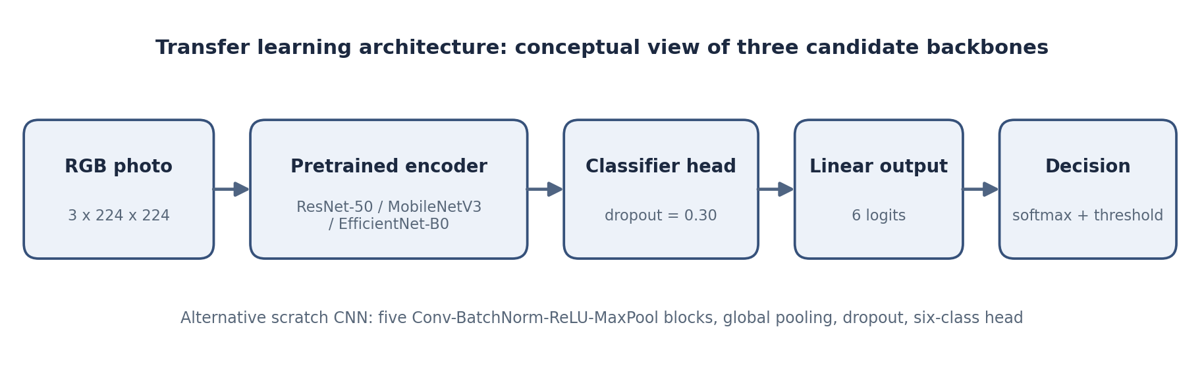
Figure 1. Six-class transfer-learning prediction architecture (schematic, derived from notebook code).
Model | Main design | Role
HOG + SVM | HOG + HSV histogram + LBP; PCA; RBF SVM; C tuned on validation | Classical baseline
Scratch CNN | Five convolutional blocks + global average pooling + dropout 0.30 | Learning-from-scratch baseline
ResNet-50 | Residual connections; six-class classifier | Higher-cost reference
MobileNetV3-Large | Efficient depthwise/mobile blocks; ImageNet weights | Edge candidate
EfficientNet-B0 | MBConv-style efficient backbone; ImageNet weights | Edge candidate

2.4 Implementation Workflow
The notebook downloads TrashNet, indexes files and records data-quality issues, creates group-aware splits, defines training and evaluation transforms, trains the two baselines and three transfer models, then selects a model using validation macro-F1 subject to an edge-compute threshold. The held-out test split is used for final metrics, uncertainty estimates, class-level analysis and error plots. Finally, it prepares Grad-CAM visualisations, ONNX/INT8 comparison and a confidence-rejection decision rule.
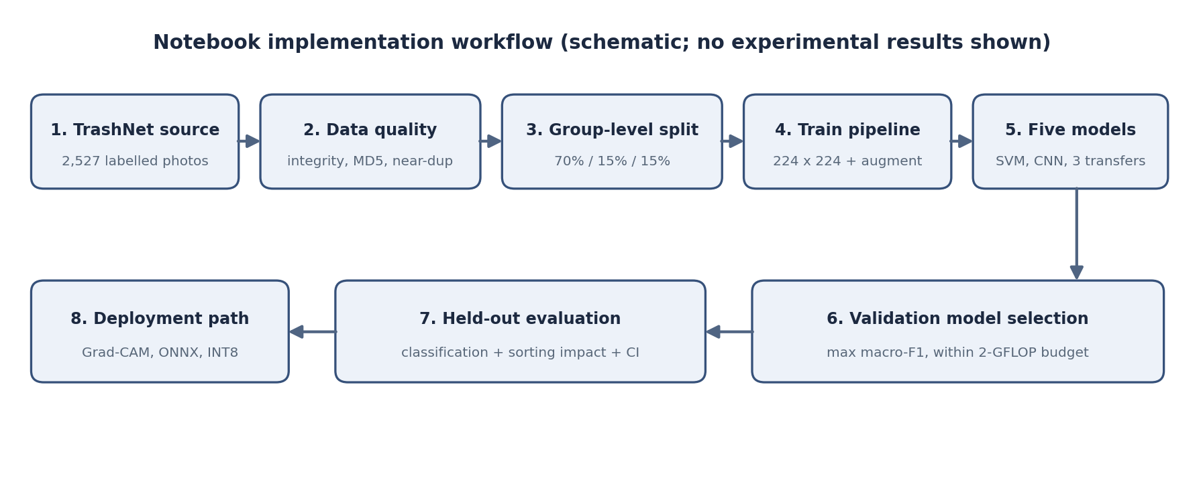
Figure 2. End-to-end Phase 2 processing workflow (schematic, not a measured experiment).

3. MODEL TRAINING AND EXPERIMENTAL SETUP
Hyperparameter | Selected value / procedure
Optimizer | AdamW for CNN and transfer models
Loss function | Class-weighted categorical cross-entropy (PyTorch CrossEntropyLoss) with label smoothing 0.10
Learning rate | Scratch CNN: 1 × 10⁻³; transfer head: 1 × 10⁻³; backbone: 1 × 10⁻⁴
Batch size | 32
Epochs | Scratch CNN: up to 30; transfers: 2 head-only warm-up + up to 15 full fine-tuning
Regularization / dropout | Weight decay 0.01; dropout 0.30; augmentation + label smoothing
Early stopping / checkpoint | Validation macro-F1, patience 8 (scratch) or 5 (transfer); restore best weights
Learning-rate scheduling | Cosine annealing within each training stage
Mixed precision | Automatic FP16 autocast and gradient scaling when CUDA is available

3.1 Training Procedure
Each model receives the same labelled split and evaluation preprocessing. For the transfer-learning models, the original 1,000-class ImageNet classifier is replaced by a six-class head. The first two epochs train only the new classification head while the pretrained backbone remains frozen. The second stage unfreezes the entire network and uses a lower learning rate for the backbone to avoid disrupting useful pretrained features. The validation macro-F1 determines early stopping and the checkpoint to retain.
The SVM baseline constructs shape (HOG), colour (HSV histogram) and texture (LBP) descriptors, standardises the resulting feature vector and applies PCA to retain 95% of variance. Its regularisation value C is selected from 1, 10 and 100 using validation macro-F1. For neural models, the training loop records accuracy and loss per epoch. Models are compared using consistent held-out metrics, and only architectures that meet the 2-GFLOP criterion compete for the final deployment selection.

3.2 Training Evidence
REQUIRED BEFORE SUBMISSION: paste genuine Colab outputs from the completed notebook run, such as the device/version line, epoch logs for each model, validation checkpoint selection, and the model comparison summary. The uploaded notebook has execution_count = None for all 24 cells and no saved output objects.
Evidence | Where the notebook generates it | Status
Environment and training logs | Setup cell; training-loop / model cells | Pending execution
Training/validation curves | results/figures/curves_*.png | Pending execution
Model and compute comparison | results/figures/10_model_comparison.png | Pending execution
Selected model name | Validation selection code after three transfer models | Pending execution

4. RESULTS AND PERFORMANCE ANALYSIS
The evaluation code is implemented, but no numerical results are available in the uploaded notebook or as separate result artefacts. Therefore, every metric below is clearly marked as pending rather than supplying unsupported performance values. Complete these entries using the generated output from notebook Section 20 and the CSV files under results/.
Metric | Training | Validation | Test
Accuracy | Pending run | Pending run | Pending run
Loss | Pending run | Pending run | Pending run
Precision (macro) | Not logged per epoch | Pending run* | Pending run
Recall (macro) | Not logged per epoch | Pending run* | Pending run
F1-score (macro) | Not logged per epoch | Pending run | Pending run

*The notebook uses validation macro-F1 for stopping; detailed validation precision/recall can be computed from saved predictions if needed. Do not confuse missing logged results with a numeric zero.
The notebook also prepares a five-model comparison reporting test accuracy, precision, recall, macro-F1, ROC-AUC, classification average precision, parameters, FLOPs and CPU latency. None of these measurements is yet observable from the attached notebook.
Model | Test accuracy | Macro-F1 | CPU latency | Edge-budget status
HOG + SVM | Pending | Pending | Pending | Not the selected neural candidate
Scratch CNN | Pending | Pending | Pending | Baseline
ResNet-50 | Pending | Pending | Pending | Expected above 2 GFLOPs; verify
MobileNetV3-Large | Pending | Pending | Pending | Evaluate against 2-GFLOP budget
EfficientNet-B0 | Pending | Pending | Pending | Evaluate against 2-GFLOP budget

4.1 Learning Curves
Insert the notebook-generated training-versus-validation loss, accuracy and macro-F1 plots here after completing training. Learning curves show whether performance improves during optimisation and whether widening training-validation gaps indicate overfitting. The supplied notebook defines these plots but does not contain exported image files.
Figure placeholders: results/figures/curves_scratch_cnn.png, curves_resnet_50.png, curves_mobilenetv3_large.png, curves_efficientnet_b0.png (confirm actual filenames when the notebook finishes).

4.2 Evaluation Outputs
Required final outputs are the confusion matrices, per-class classification report, ROC and precision-recall curves, Grad-CAM examples and confidence-threshold coverage graph. Class-specific diagnostics are essential because the residual trash category is much smaller than paper. The implementation also estimates recycling contamination, loss of recyclables to residual waste and cross-material sorting errors.
Evaluation artefact | Notebook-generated file / evidence
Comparison figure | results/figures/10_model_comparison.png
Confusion matrices | results/figures/11_confusion_matrices.png
ROC and precision-recall plots | results/figures/12_roc_pr_curves.png
Per-class report | results/per_class_report.csv
Grad-CAM explanation panels | results/figures/13_gradcam.png
Confidence reject-option plot | results/figures/14_reject_option.png
Final narrative and summary table | results/results_summary.md

4.3 Result Interpretation
After execution, compare the selected transfer-learning model with HOG + SVM and the scratch CNN using measured test accuracy and macro-F1. State which classes are most frequently confused and whether common look-alikes include clear plastic versus glass or paper versus thin cardboard. Read the confusion matrix rather than presuming the weakest class. The project includes 1,000-resample bootstrap confidence intervals and exact McNemar tests to assess whether performance differences are meaningful on a finite test set.
The deployment decision must not use test accuracy alone: the source code selects the highest validation macro-F1 among networks under 2 GFLOPs. Comment on this selected model’s parameters, single-thread CPU latency and any effect of static INT8 quantisation. The reject-option threshold is chosen using validation predictions, and evaluation should report how many test images are automatically sorted versus referred to a human. Numerical interpretation remains pending until actual outputs exist.

5. TESTING AND VALIDATION
Test cases below describe the intended prediction check; they are not recorded successful predictions. The actual class, model confidence, and final bin recommendation must be copied from the notebook’s classify(...) outputs after running the held-out sample demonstration.
Test case / input | Expected outcome | Actual prediction | Observation
Held-out image of a glass bottle | glass → Dry: glass | Pending run | Check confidence and contamination risk
Held-out image of cardboard packaging | cardboard → Dry: paper and cardboard | Pending run | Check against paper look-alikes
Held-out image of residual trash | trash → Residual (non-recyclable) | Pending run | Check small-class recall / reject threshold

Validation uses a fixed seed, stratified group-level partitioning and checkpoint selection on the validation set. The test data is reserved for final evaluation, and errors should be inspected using the confusion matrix and selected Grad-CAM overlays. Uncertain predictions are routed to manual checking rather than forcing an automated sort. The demonstration routine accepts a photograph and returns a class, confidence, recommended stream and the three highest-probability classes.
REQUIRED BEFORE SUBMISSION: insert at least three actual input/output screenshots and mark one incorrect or low-confidence case if one occurs. Avoid labelling the illustrative test scenarios above as observed results.

6. CONCLUSION AND FUTURE SCOPE

6.1 Conclusion
The Phase 2 work converts the earlier waste-classification proposal into a reproducible implementation notebook that prepares TrashNet data, defines two baselines and three deep transfer-learning models, sets common training and evaluation procedures, and includes methods for edge-aware model choice, uncertainty analysis, interpretability and deployment optimisation. This establishes the technical framework for intelligent dry-waste material identification. Because the submitted notebook has no saved training or test outputs, it is not yet possible to state which model wins, quantify accuracy or claim a tested deployed application. The final conclusion should be updated from results/results_summary.md after a complete notebook run.

6.2 Limitations
- TrashNet images typically contain single, relatively clean items against simple backgrounds; performance may decrease for wet, torn, mixed or partially hidden real-world waste.
- The dataset has relatively few residual-trash images, which creates class-imbalance and variety challenges.
- An RGB photograph cannot reliably reveal the composition of multilayer packaging or visually similar transparent materials.
- The six-class taxonomy does not cover wet, sanitary, e-waste, batteries and other special-care materials.
- Near-duplicate grouping cannot fully guarantee that different views of the same physical object are separated.
- CPU latency and quantised accuracy measured on a general computer will not automatically represent performance on an actual smart-bin board.
- The notebook has not yet been executed in the supplied record, so empirical effectiveness remains unverified.

6.3 Future Scope
- Complete the full Google Colab run and attach measured tables, genuine confusion matrices, learning curves and prediction examples.
- Test model generalisation on photographs collected locally in realistic bins, including Indian packaging and poor-lighting cases.
- Extend the label set to wet, sanitary, hazardous and composite packaging categories.
- Use an object-detection or instance-segmentation model for mixed piles rather than only single-item classification.
- Benchmark the ONNX INT8 model on a real edge processor and integrate a camera with a safe diverter or guided-bin interface.
- Add human review for uncertain items and collect operator corrections for iterative retraining.

REFERENCES
[1] G. Thung and M. Yang, "Classification of trash for recyclability status," Stanford CS229 Project Report, 2016. Dataset: https://github.com/garythung/trashnet
[2] R. A. Aral et al., "Classification of TrashNet dataset based on deep learning models," in Proc. IEEE Int. Conf. Big Data, 2018.
[3] K. He, X. Zhang, S. Ren and J. Sun, "Deep residual learning for image recognition," in Proc. IEEE CVPR, 2016.
[4] A. Howard et al., "Searching for MobileNetV3," in Proc. IEEE/CVF ICCV, 2019.
[5] M. Tan and Q. V. Le, "EfficientNet: Rethinking model scaling for convolutional neural networks," in Proc. ICML, 2019.
[6] R. R. Selvaraju et al., "Grad-CAM: Visual explanations from deep networks via gradient-based localization," in Proc. IEEE ICCV, 2017.
[7] I. Goodfellow, Y. Bengio and A. Courville, Deep Learning. MIT Press, 2016.
[8] PyTorch and torchvision documentation: https://pytorch.org/
[9] ONNX Runtime, "Quantize ONNX models": https://onnxruntime.ai/

APPENDIX

A. Source code and reproducibility
Supplied code: Smart_Waste_Classification.ipynb (the attached Python notebook). Public repository link: [INSERT ONLY IF A PUBLIC REPOSITORY EXISTS].
To obtain report-ready results: open the notebook in Google Colab, enable a T4 GPU, execute the cells in order, save the generated smart_waste_results.zip, and copy results/results_summary.md into the Results and Conclusion sections. Insert the actual figure images into Sections 3–5. Run settings: seed 42, batch size 32, target 224 × 224, and the split and model-selection rules described above.

B. Additional screenshots and sample outputs
[ATTACH AFTER EXECUTION] training logs, model-comparison chart, training curves, confusion matrices, Grad-CAM overlays, confidence-rejection plot, and at least three genuine test-case predictions.

C. Student signature and faculty remarks
Student signatures (Tanmay Badhe, Swayam Netke): ________________________ Faculty remarks: ________________________

D. Phase 2 submission checks
- Run the entire notebook without errors and save the final Colab notebook showing execution counts and outputs.
- Record the actual runtime (Python/PyTorch, CPU/GPU), cleaned dataset counts and split sizes.
- Replace every Pending run entry with a measured value; insert real plots and output screenshots.
- Update the abstract and conclusion with the selected model and its verified test accuracy and macro-F1.
- Check the details of both team members (Tanmay Badhe and Swayam Netke) and the repository link before submitting the signed report.

E. Output package expected from notebook
Result file or folder | Use in final report
smart_waste_results.zip | Notebook-created bundle for archiving figures and measured tables
results/results_summary.md | Narrative results and model comparison for Section 4
results/split.csv | Audited train/validation/test sample allocation
results/per_class_report.csv | Per-category precision, recall, F1 and sample support
results/figures/ | Genuine training curves, error plots, Grad-CAM and confidence analysis

